**CS 555**

**HOMEWORK 1**

**Name:** Ivan Sangines Escrig

**ID#:** 968606

**Instructor:** Dr. Mahmood

**Date:** September 12, 2018

**TABLE OF CONTENT**

**INTRODUCTION** 3

**SCREENSHOTS:** 4

**SOURCE CODE:** 10

**CONCLUSION:** 13

**INTRODUCTION**

The porpuse of this assignment is to get used to Visual studio and understand better the concepts explained in class about HTML. This will be achieved by doing the first examples of the handout in order to practice the different tags and elements of HTML.

The ProductPage html file corresponds to the first web page we were asked to create.

The Book html file corresponds to the second web page we were asked to create

**SCREEN SHOTS:**

**Handout Examples:**

Here we can see one of the outputs after trying the code for the video in the handout.



Here we can see the screenshot after trying the HTML code in order to open an audio. Even though the link for the audio was not working, I now know how to correctly upload an audio to a webpage.

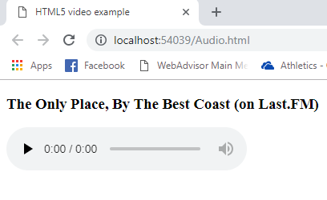

In this screenshot we can see the color Menu after trying the example given in the handout. I have also tried changing the font family and color in order to get used to html.

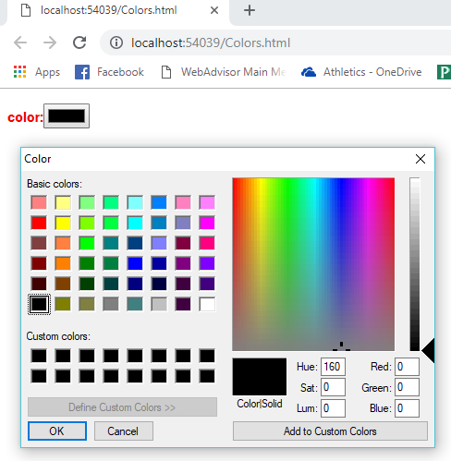

Here we have more outputs after trying different examples from the handout. We can see the elements number picker and Range sliders.

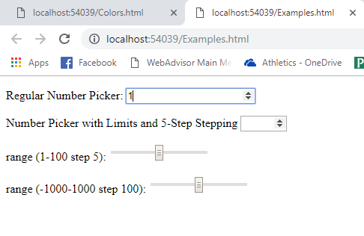

In this example we can appreciate two different input tags (Text and Password). As well as checkers and buttons.

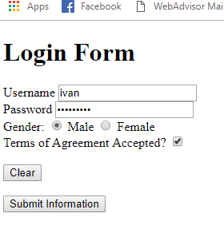

**Exercise 1:**

On this screenshot we can see the webpage we were asked to create. In order to create it, I used a form and the <pre> tag. Whenever we code in the tag <pre>, it allows us to format the webpage the way we prefer. The page will be show respecting the format that it has on the HTML code.

As we can see, there are some default values for product id and price. This can be done using placeholders. I have also created some css code for the inputs and a class called .myspace. I used them in order to format my page and respect some margins.

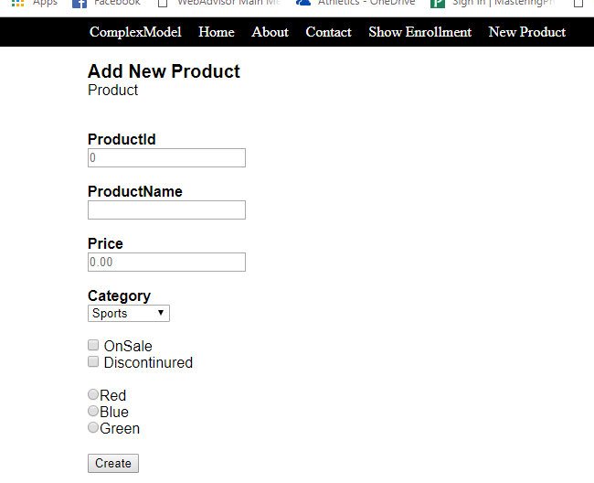

**Exercise 2:**

Here we can see the exercise 2. I tried some things like the input type email, place holders for the email and the reset type button. For the input type email, whenever we click on submit, an error will be shown if the text on the first text box is not on email format. On the other hand, the radio buttons belong to two different block so a selection is allowed for each one.

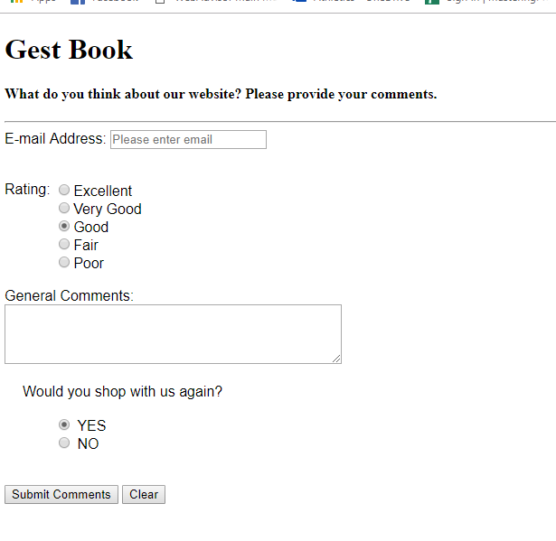

**SOURCE CODE:**

**Exercise 1:**

<!DOCTYPE html>

<html>

<head>

<meta charset="utf-8" />

<style>

input{

margin:0;

}

.myspace {

margin-left: 80px;

}

</style>

</head>

<body style="margin:0">

<p style="background-color:black; margin:0; line-height:2">

<span style="color:white; margin:100px">

<label>ComplexModel</label>

<label style="margin-left:15px">Home</label>

<label style="margin-left:15px">About</label>

<label style="margin-left:15px">Contact</label>

<label style="margin-left:15px">Show Enrollment</label>

<label style="margin-left:15px">New Product</label>

</span>

</p>

<form>

<pre class="myspace" style="font-family:Arial">

<span style="font-size:20px"><b>Add New Product</b></span>

Product

<b>ProductId</b>

<input type="text" name="id" placeholder="0" />

<b>ProductName</b>

<input type="text" name="nm" />

<b>Price</b>

<input type="text" name="id" placeholder="0.00" />

<b>Category</b>

<select>

<option value="sports">Sports</option>

<option value="electronic">Electronics</option>

<option value="books">Books</option>

</select>

<input type="checkbox" name="chk"/> OnSale

<input type="checkbox" name="chk2"/> Discontinured

<input type="radio" name="color" value="Red" />Red

<input type="radio" name="color" value="Blue" />Blue

<input type="radio" name="color" value="Green" />Green

<input type="button" name="btn1" value="Create" />

</pre>

</form>

</body>

</html>

**Exercise 2:**

<!DOCTYPE html>

<html>

<head>

<meta charset="utf-8" />

<style>

input{

margin:0;

}

.myspace {

margin-left: 80px;

}

</style>

</head>

<body style="margin:0">

<p style="background-color:black; margin:0; line-height:2">

<span style="color:white; margin:100px">

<label>ComplexModel</label>

<label style="margin-left:15px">Home</label>

<label style="margin-left:15px">About</label>

<label style="margin-left:15px">Contact</label>

<label style="margin-left:15px">Show Enrollment</label>

<label style="margin-left:15px">New Product</label>

</span>

</p>

<form>

<pre class="myspace" style="font-family:Arial">

<span style="font-size:20px"><b>Add New Product</b></span>

Product

<b>ProductId</b>

<input type="text" name="id" placeholder="0" />

<b>ProductName</b>

<input type="text" name="nm" />

<b>Price</b>

<input type="text" name="id" placeholder="0.00" />

<b>Category</b>

<select>

<option value="sports">Sports</option>

<option value="electronic">Electronics</option>

<option value="books">Books</option>

</select>

<input type="checkbox" name="chk"/> OnSale

<input type="checkbox" name="chk2"/> Discontinured

<input type="radio" name="color" value="Red" />Red

<input type="radio" name="color" value="Blue" />Blue

<input type="radio" name="color" value="Green" />Green

<input type="button" name="btn1" value="Create" />

</pre>

</form>

</body>

</html>

**Conclusion:**

After doing this assignment I was able to practice different attributes about HTML. Reading and doing all the examples from the handout helped me to understand better how HTML works.